For Immediate Release: March 12, 2021

TAYLOE PIGGOTT GALLERY ANNOUNCES A YEAR ON MAGNOLIA ROAD
AN EXHIBITION OF NEW WORK BY ARTIST SEBASTIAN BLANCK

Exhibition Dates: 31 March – 02 June 2021

Tayloe Piggott Gallery is pleased to present A Year on Magnolia Road an exhibition of drawings, and paintings by artist Sebastian Blanck. Sebastian Blanck is a New York-based artist who conjures the nostalgic interaction between man and nature. Using vibrant colors to craft familiar outdoor scenes, Blanck captures fleeting yet touching moments in life. Blank’s most recent body of work for this exhibition includes broad perspective seasonal vignettes evoking the solitary nature of passing time.

Blanck paints compelling scenes that express small, intimate, moments of life. His works on canvas range from depicting vivid portraits of loved ones and children at play, to also capturing quotidian experiences in bright, saturated colors. His black and white ink on paper works, invite the viewer to step into his cherished world. Often touching and emotional in spirit, Blanck’s work displays both a familiarity with each subject and a commitment to connecting individuals through the power of nostalgic, bold imagery.

Like the Impressionists before him, Blanck challenges the viewer to stand still and lose oneself in the narratives through strong lines, vibrant color, and playful composition. Blanck’s paintings are an expression of the feelings that connect us with one another. Working from photographs, he has tasked himself to making a painting a day. This structure allows him to work quickly and intuitively without giving way to overworked canvases but reveling in the unintended mistakes and possibilities.

Blanck received his BFA from Rhode Island School of Design. In the late 1990’s he worked as an assistant for American figurate artist, Alex Katz. Although influenced by Katz, Blanck’s work varies greatly due to the intimacy of his subjects and the evidence of his hand in the work.

Throughout his career, he has had solo exhibitions in California, Colorado, Maryland, New York, Switzerland, Sweden, and Wyoming and had been featured in group shows in New York, Chicago and Sweden. In 2001, he was a visiting artist at the American Academy in Rome. Widely recognized for his musical contributions in addition to his painting, Blanck has exhibited at galleries in the United States and Europe. His work has been reviewed in publications including New York Magazine, Artforum, Paper Magazine, and The New Yorker.

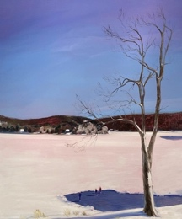 | Sebastian Blanck  Ice Rink Lake, 2021  Oil on canvas  50 x 60 inches
 | Sebastian Blanck  Cross Country, 2021  Oil on canvas  12 x 15 inches
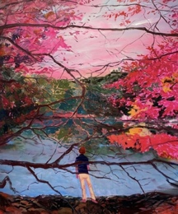 | Sebastian Blanck  Behind the Branches, 2021  Oil on canvas  60 x 72 inches

TAYLOE PIGGOTT GALLERY

Specializing in modern and contemporary art, Tayloe Piggott Gallery expresses a sharp appreciation for exceptional aesthetic vision. Based in Jackson, Wyoming, the gallery showcases sophisticated, unique artworks in a modern setting. Always interested in artistic discovery, the gallery expanded to create The Project Space: a collaborative place for the local and global community to share ideas, showcase work, host events, and expand artistic concepts. Mindful and thought-provoking, Tayloe Piggott Gallery aims to enrich cultural dialogue by bringing remarkable artists into an already flourishing arts community.

From first time buyers to seasoned collectors, our gallery assists a wide range of clients with the intricacies of collecting contemporary art. Our staff has the knowledge and expertise to facilitate art acquisitions, advise collection management, and curate the interiors of private spaces.

Media contact: Katie Franklin, katie@tayloepiggottgallery.com

